Java AWT Tutorial

**Java AWT** (Abstract Window Toolkit) is *an API to develop Graphical User Interface (GUI) or windows-based applications* in Java.

Java AWT components are platform-dependent i.e. components are displayed according to the view of operating system. AWT is heavy weight i.e. its components are using the resources of underlying operating system (OS).

The java.awt [package](https://www.javatpoint.com/package) provides [classes](https://www.javatpoint.com/object-and-class-in-java) for AWT API such as [TextField](https://www.javatpoint.com/java-awt-textfield), [Label](https://www.javatpoint.com/java-awt-label), [TextArea](https://www.javatpoint.com/java-awt-textarea), RadioButton, [CheckBox](https://www.javatpoint.com/java-awt-checkbox), [Choice](https://www.javatpoint.com/java-awt-choice), [List](https://www.javatpoint.com/java-awt-list) etc.

## **Why AWT is platform independent?**

Java AWT calls the native platform calls the native platform (operating systems) subroutine for creating API components like TextField, ChechBox, button, etc.

For example, an AWT GUI with components like TextField, label and button will have different look and feel for the different platforms like Windows, MAC OS, and Unix. The reason for this is the platforms have different view for their native components and AWT directly calls the native subroutine that creates those components.

In simple words, an AWT application will look like a windows application in Windows OS whereas it will look like a Mac application in the MAC OS.

## **Java AWT Hierarchy**

The hierarchy of Java AWT classes are given below.

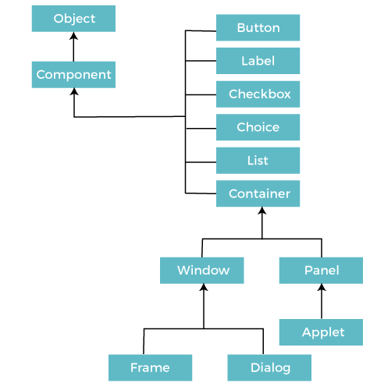

### **Components**

All the elements like the button, text fields, scroll bars, etc. are called components. In Java AWT, there are classes for each component as shown in above diagram. In order to place every component in a particular position on a screen, we need to add them to a container.

### **Container**

The Container is a component in AWT that can contain another components like [buttons](https://www.javatpoint.com/java-awt-button), textfields, labels etc. The classes that extends Container class are known as container such as **Frame, Dialog** and **Panel**.

It is basically a screen where the where the components are placed at their specific locations. Thus it contains and controls the layout of components.

#### **Note: A container itself is a component (see the above diagram), therefore we can add a container inside container.**

**Types of containers:**

There are four types of containers in Java AWT:

1. Window
2. Panel
3. Frame
4. Dialog

### **Window**

The window is the container that have no borders and menu bars. You must use frame, dialog or another window for creating a window. We need to create an instance of Window class to create this container.

### **Panel**

The Panel is the container that doesn't contain title bar, border or menu bar. It is generic container for holding the components. It can have other components like button, text field etc. An instance of Panel class creates a container, in which we can add components.

### **Frame**

The Frame is the container that contain title bar and border and can have menu bars. It can have other components like button, text field, scrollbar etc. Frame is most widely used container while developing an AWT application.

## **Useful Methods of Component Class**

|  |  |
| --- | --- |
| **Method** | **Description** |
| public void add(Component c) | Inserts a component on this component. |
| public void setSize(int width,int height) | Sets the size (width and height) of the component. |
| public void setLayout(LayoutManager m) | Defines the layout manager for the component. |
| public void setVisible(boolean status) | Changes the visibility of the component, by default false. |

## **Java AWT Example**

To create simple AWT example, you need a frame. There are two ways to create a GUI using Frame in AWT.

1. By extending Frame class (**inheritance**)
2. By creating the object of Frame class (**association**)

**AWTExample1.java**

// importing Java AWT class

**import** java.awt.*;

// extending Frame class to our class AWTExample1

**public** **class** AWTExample1 **extends** Frame {

   // initializing using constructor

   AWTExample1() {

      // creating a button

      Button b = **new** Button("Click Me!!");

      // setting button position on screen

      b.setBounds(30,100,80,30);

      // adding button into frame

      add(b);

      // frame size 300 width and 300 height

      setSize(300,300);

      // setting the title of Frame

      setTitle("This is our basic AWT example");

      // no layout manager

      setLayout(**null**);

      // now frame will be visible, by default it is not visible

      setVisible(**true**);

}

  // main method

**public** **static** **void** main(String args[]) {

// creating instance of Frame class

AWTExample1 f = **new** AWTExample1();

  }

 }

**AWTExample2.java**

// importing Java AWT class

**import** java.awt.*;

// class AWTExample2 directly creates instance of Frame class

**class** AWTExample2 {

   // initializing using constructor

   AWTExample2() {

      // creating a Frame

      Frame f = **new** Frame();

      // creating a Label

      Label l = **new** Label("Employee id:");

      // creating a Button

      Button b = **new** Button("Submit");

      // creating a TextField

      TextField t = **new** TextField();

      // setting position of above components in the frame

      l.setBounds(20, 80, 80, 30);

      t.setBounds(20, 100, 80, 30);

      b.setBounds(100, 100, 80, 30);

      // adding components into frame

      f.add(b);

      f.add(l);

      f.add(t);

      // frame size 300 width and 300 height

      f.setSize(400,300);

      // setting the title of frame

      f.setTitle("Employee info");

      // no layout

      f.setLayout(**null**);

      // setting visibility of frame

      f.setVisible(**true**);

}

// main method

**public** **static** **void** main(String args[]) {

// creating instance of Frame class

AWTExample2 awt_obj = **new** AWTExample2();

}

}